- How do you guys run sourcing
- Standard product to market calendar
- What software tools do you use?
- Team shape?
- People at brands but not necessarily in supply chain
  - Super easy integration; still work how you normally would
    - The’re hesitant about change management or a new system
    - Make it passive
- People at brands in supply chain
  - Really map out your process by capturing all communication
  - SG&A is main motivation and business case

Will’s notes
- How to improve calendar
- Add embroidery stuff
- Not at cotopaxi today
- Sustainability, cost
- Quality product
- Its all about quality lead time
- “Days of big teams are gone”
  - Used to be sweater manager
  - Much lower
- At Carters, her team was 13 people and then got laid off
  - Moved their team to Asia
- Have team in Kansas in lululemon
  - 8 in usa, 12 in asia
- Software
  - Excel
  - Powerbi
- Challenge right now
  - Poor systems
  - Find data
- “No perfect system”
- If you are making the same thing, there are systems
- Problem is the fashion space, because styles are always changing
  - 80% is fashion
  - 20% if basic
- THey use FlexPLM
- Wants to see all costs or margin for a season
- Communication: slack
- Part of project that vet software
  - Due to cost or
  - Useless
- Reporting was really important
- Communication strategy / visibility change
  - We have to be fluid
  - Have to measure success(?)
- Some metrics that are easy: on time rate
- Is my duty rate accurate
- Manny’s AI
  - She feels like this is more cost; not for her since she is fashion
- Her feedback on showing her this prototype:
- 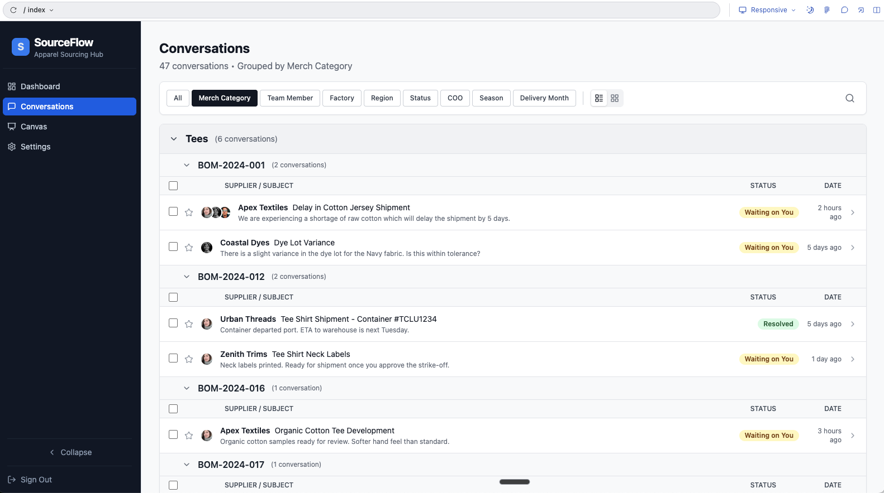
  - Her general feedback was this looks cool but didn’t really connect with her
  - She said she doesn’t look at things in terms of a merch hierarchy in terms of sourcing but thinks in terms of the calendar. She said she wanted to see conversations overlaid on a calendar. When she saw merch category she said she wasn’t sure this was for her
  - One thing she also brought up was the 70 email thread thing
    - She said it would be really nice to see messages as organized by:
      - Waiting on you specifically or someone on your team or the supplier (she said there are just too many messages to keep track of)
      - See emails that need your reply
    - When she sees a 70 email thread, she is like “where do I start?”
  - She said that communication is now happening across slack shared channels, whatsapp, email and wechat. Ideally she said communication from all those would be in there
    - She said she recently has been hearing people want to go to all slack
  - When I showed the cost discrepancy overlay underline in the sample email she was skeptical. She said that its way more than just the overall cost but that you really need to see a breakdown and capture that sub costs of an item shift and can influence the overall price
    - I kinda wonder if we could use LLMs to make costs explainable and pull in all the subcomponents easily and explain how the subcomponents ended up in a certain place
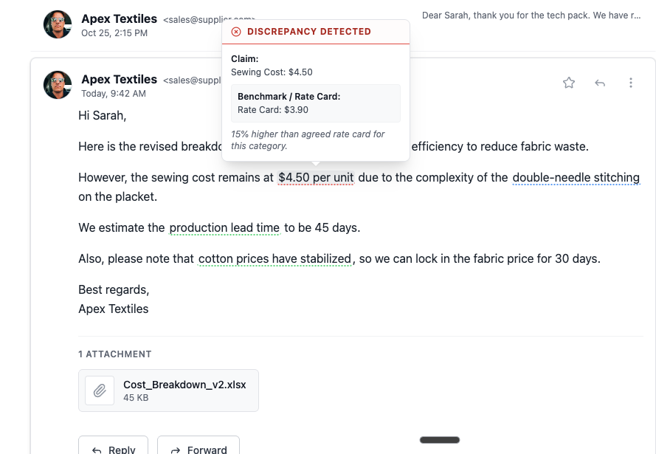
- Debrief with just Will and Richard
  - She thinks this systems work well for basics but not for fashion
  - She didn’t really feel like an early adopter and is probably a good person to think about as a person to build for and try to win over. If she is into it, then broader market is ready
  - She said she is happy to chat again
  - It does sound like hindsighting could be a thing or module
    - She wants to know why we missed something
  - She also kept bringing up reporting as well
  - I also wonder if based on emails we could make cool communication timelines and maps for styles so folks could see how things happen overlaid on a calendar
    - Thinking sorta like how Lucidic generates agent maps automatically based on logging LLM stuff

Richard’s notes:
- All people need to be on board with the calendar
- Some are 12-18 months in advance of what you see in store
- Production lead time of 45-60 days
- Transit lead time of 45 days
- In her role, she builds, owns, and drives the calendar
- “How do I improve the calendar, but first stay on calendar”
- Quince and such: vendor to USA customer direct, help to shorten calendar
  - Design closer to market
  - Buy closer to market
  - Cut lead times
- Bulk of business is setting up calendar that works for them
- Buying finished product blanks, customizing (embroidery, printing, etc) for some brands
- Everyone wants quick fast and cheap
- At cotopaxi, sustainability, ethical sourcing, cost, margin, quality, fashion
- Too hard to generalize the goals, but every company has that
- Between USA team and overseas vendors – she’s the voice
- Builds a sourcing strategy
  - Current vendors we have
  - Opportunities to get better
  - Do in the short-term 3-6 months, long-term strategy goal for COO changes
  - Mitigate duties, reduce duties, nearshore for speed
- Traveled a lot, best practices from each step of the journey
- Goal is never to make fast cheap product!
  - Thrive in sustainable quality product
- Quality is most important
- Buy low, see styles selling, the 5 that were blowing up, produce in nicaragua
  - Pay more, but not sitting on inventory that isn’t selling
- Started in the industry at jcrew, had a “knit womens manager” a “woven manager” etc – all broken out
  - 1 person at sr. director + junior people below
    - Don’t need the same passion at the junior level
    - As long as the person at the top can communicate the vision
- Carters: 13 people // massive team
  - Cut the entire team totally
  - Gave ample notice
  - Shut down the team in the US because they moved it to Asia
- Working on a project out of Kansas
  - Making lulu, champion, etc
  - Building a strategy that is long+short term
  - Team is 8 in the US + 12 in Asia
- Inherit a team
  - Who can work in excel, powerbi, who knows systems, who is passionate, who this is a career for
  - All people with different experiences + passions
  - People thrive here – hard driver
  - People who are clocked out before the end of the day
  - Some people are new mothers, some people are grandmothers
- Big company that has poor systems
  - Everything is manual and not centralized or organized
- Have worked where everything is excel-based but you can move fast, make decisions quickly
- Carters
  - 4.6bn company
  - To change a label from original to recycled cotton was a 6mo discussion
  - Had a $0.02 impact and nobody would make a decision
- Goal: baby steps to prioritize
- A lot of people are legacy/dinosaurs
  - They operate in a fashion where they just want to cut/save small amounts
  - Not factoring in all of the macro factors
- Lay out the options, let team decide
- No great/perfect system
  - If you’re making white t-shirts and you just keep carrying over
    - There are systems out there that can track that
  - But she works in fashion
    - Completely different style season over season
- 80% fashion, 20% core basics
- Working in fashion with multiple variables
  - Everything is different
  - The bom is big
- The systems are being built (PLM, costing, transparency) with basics in mind
  - Very 1:1:1
  - Doesn’t work well
  - Leadership invests in these systems because they’re “sold” these systems
  - Reality is it doesn’t work for us
- Have been a part of Cotopaxi vetting PLMs
  - New regulations coming around transparency
- Attended quite a few 2025 conferences around sustainability, transparency, ethical sourcing, mission based sourcing
  - Outside of conference, all were software people
  - Talked to a ton of them
  - 9/10 have never set foot in a factory
  - They’re missing the experience
- She’s pushing work overseas, pushing work to int’l team or to vendors/suppliers
- Especially when it comes to reporting: everything is outside the system
- Manual communication is key
  - Sometimes Slack is the new thing for local
  - WeChat, WhatsApp
- Sick for 3 weeks with the flu
  - Not a good enough excuse to not be in communication
  - What happened to the days when you could “not work”
  - So much expectation
- She has kids
  - Son works as a busboy 21
    - Move food from kitchen counter to table where people eat
    - Won’t talk to people
    - Won’t do anything else
    - “We want your son to do more and he said no”
  - Daughter is 18
- Part of a project to vet software programs
  - At cotopaxi
  - Sales pitch, demo
  - Vetted 9 products
  - 2-3 would pass on to loop in cross-functional teams
  - Due to cost, capability
    - No one system that does everything
  - Didn’t onboard any
- Have to be fluid – strategy you created today isn’t what you’re going to march on for the next 5 years
  - Revisit once every 6 months
- Working on 12-18mo window from concept to receipt
  - More about being fluid
  - Measure success
- Replaced someone who left in October and she’s starting from scratch again
  - Very personal, subjective, fluid
- Spending a lot of time to centralize information
  - Shared drive right now
- Systems are built for one style and one cost
  - Listing that work and entry 3 times is painful
  - Just want to put in the one that is final
- Wouldn’t use the interface Will showed
  - Calendar-focused
  - Achieve Spring 25 indc
  - Approval, purchase order, etc. on a cadence
  - Seeing merch categories not as helpful for her
  - Sourcing should be by season
- A lot of people walking in walk in with 80 e-mails today
  - Can’t read and comprehend them all
  - Would love to see e-mails that are bucketed
    - These are to me that need action
    - Stephanie, sourcing, important
  - “What needs my attention”
  - Have to read 80 emails to address 5 emails
- Because she works with so much fashion, she doesn’t believe the comparables/like for like can work well
- More and more people in the space say “I want to be out of emails” and go to slack, whatsapp, etc
  - Keep emails to the internal USA people, but communicate via instant messenger with the suppliers
- Too many systems
  - Suggest we have one place for all of the messaging
  - Asks vendors to put things in a chart / spreadsheet so it is easier to go back to it months later
- LatAm responds to calls, but overseas the time zone issues are real
- The 99c store
  - They don’t go and have merchants and design making products at 50c and selling at 99c
  - They have people that go and find products that are $0.50 and cell at $0.99
  - Crappy clothing
  - Candles
  - But go back 6mo from now and there’s no cohesive collection
  - Just a combination of hitting a price
- Different from properly merchandised collection

To what extent are these true for you?

Too much time developing the wrong product / not enough time developing the right product before adoption | Leaving money on the table by not knowing “should cost” or negotiating effectively | Inefficient P2M process with handoffs between merch, product development and supply chain team
Hard to visualize how assortment will translate to ecommerce and in-store execution | Hard to stay organized with supplier communication sprawl and seeing impact of everything on commercial plan | Too much time doing admin tasks and not enough time on looking at higher-leverage tasks
Visibility into things that drive cost and actual estimated landed cost |  | Designers think they know costing, but they don't actually know costing because there are too many variables that are constantly changing

